Due Date is **Monday Week 7 – 29th of August**

**Atoms and Elements Project**

**PART 1 – MODELS:**

Task: Create a model or poster to display in the class that shows **an Atom**

Your presentation piece must:

* Be of one of the **first 20** elements.
* **Have the correct number** of protons, electrons and neutrons for the atom that you have chosen.
* **Identify** the protons, electrons, neutrons and nucleus.

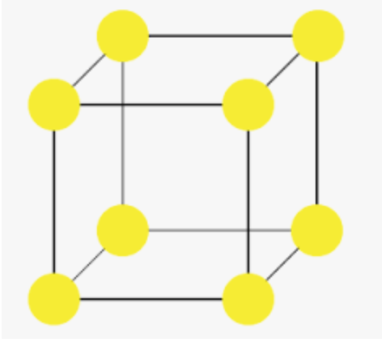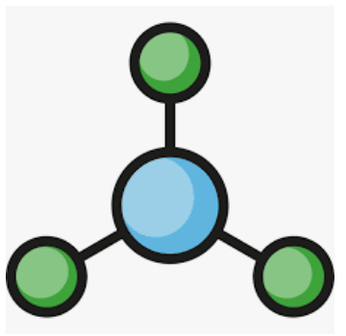

**Present a Compound Molecule and an Elemental Lattice**

* Clearly name the chemical you have chosen for your compound molecule.
* Your **compound molecule** must specify the names and numbers of each of the elements in it.
* Your **elemental lattice** must state what is the element in it.

**PART 2 – PROFILE**

Task: Create an element profile/element information sheet.  
You can choose ANY element EXEPT Noble Gasses and elements 93 – 118

Your Profile Element does NOT have to be the same as the one chosen for the atom model.

Your element profile/information sheet must include for your chosen element:

* Name of the element
* Picture/ Symbol
* Atomic number
* Atomic mass
* Classification (metal, non-metal or metalloid)
* Physical properties
* State if the element exists as a molecule, lattice or single atom
* State THREE compounds that this element is a part of and have pictures of these compounds
* A video or photo of a chemical reaction that this element is involved in and a description of this reaction
* 2 Uses of the element
* 3 Fun facts: include any interesting facts about your element

You may present Part 2 of this assignment in any way that you decide such as a Facebook/Instagram profile, song, video, podcast, interview - **BE CREATIVE!!!**

**Group Members: ________________________________________**

|  |  |  |
| --- | --- | --- |
| **Section** | **Checklist** | **Marks** |
| Atom | * **Correct number** of protons, neutrons and electrons * **Correct labelling** of neutrons, protons, electrons and Nucleus * **Creativity/Innovation/Effort** in presentation | 1  1  1-3 |
| Molecule and Lattice | * **Compound** molecule and **Elemental** lattice * **Correct** **elements and numbers** in the compound * **Creativity/Innovation/Effort** in presentation | 1  1  1-3 |
| Profile | * **All information included** * Name of the element * Picture, Symbol, Atomic number, Atomic mass * Classification * State if the element exists as a molecule, lattice or single atom * 3 compounds that this element is a part of and pictures * Chemical Reaction element is involved in * 2 Uses * 3 Facts * **Creativity/Innovation/Effort in presentation** | 1-2  1-3 |

**Total: /15**

**Group Members: ________________________________________**

|  |  |  |
| --- | --- | --- |
| **Section** | **Checklist** | **Marks** |
| Atom | * **Correct number** of protons, neutrons and electrons * **Correct labelling** of neutrons, protons, electrons and Nucleus * **Creativity/Innovation/Effort** in presentation | 1  1  1-3 |
| Molecule and Lattice | * **Compound** molecule and **Elemental** lattice * **Correct** **elements and numbers** in the compound * **Creativity/Innovation/Effort** in presentation | 1  1  1-3 |
| Profile | * **All information included** * Name of the element * Picture, Symbol, Atomic number, Atomic mass * Classification * State if the element exists as a molecule, lattice or single atom * 3 compounds that this element is a part of and pictures * Chemical Reaction element is involved in * 2 Uses * 3 Facts * **Creativity/Innovation/Effort in presentation** | 1-2  1-3 |

**Total: /15**